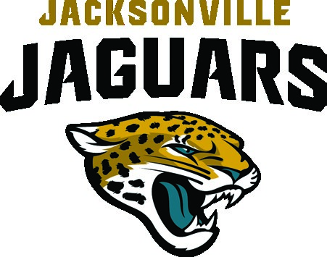



Historically Black College or University (HBCU)
- Edward Waters University
- Florida A&M University
- Florida Memorial University

Educational Institutions and Affiliated Organizations Support
- Clay County School District
- Duval County School District
- Flagler College
- Florida School for the Deaf and the Blind
- Nassau County School District
- Pi Eta Omega Chapter of Alpha Kappa Alpha Sorority
- St. Johns County School District
- University of North Florida

Historical, Cultural and Tourism Organizations
- Colonial Research Associates
- First Coast NPHC (National PanHellenic Council)
- Fort Mose Historical Society • Gullah Geechee Cultural
Heritage Corridor Commission • Lincolnville Museum and Cultural Center
- Middle Passage Ceremonies and Port Makers Project
- Sea Islands Heritage Society
- St. Johns County Cultural Council
- SJC Cultural Events, Inc

(operators of the St. Augustine
Amphitheatre)
- St. Johns County Visitors and Convention Bureau • The Anniversary to
Commemorate the Civil Rights
Demonstrations, Inc. (ACCORD)
- The Stetson Kennedy Foundation
- Visit Jacksonville

Business Community
- Advent Health
- Bailey Group
- Florida Blue
- Historic Tours of America
- Jacksonville Jaguars
- JAXUSA Partnership
- Leo C. Chase and Associates, Inc.
- Northrup Grumman
- Old Town Trolley Tours
- PGA Tour
- Palm Coast - Flagler Chamber of Commerce
- State Farm Agent Tony Pearson
- St Johns Chamber of Commerce
- The Collage Companies • TouchPoint Innovative Solutions

Regional Public/Government
- City of Jacksonville
- City of Palm Coast
- City of St. Augustine
- City of St. Augustine Beach
- Jacksonville Aviation Authority

- JaxPort
- JaxUSA Partnership
- Nassau County
- Northeast Florida Regional Council
- St. Johns County
- St. Johns Library Services
- United States District Court – Middle District of Florida

Regional Support Organizations
- American Legion
- Flagler County Branch NAACP
- Jacksonville Jaguars
- Jessie Ball duPont Fund • Habitat for Humanity of St.
Augustine/St. Johns County
- Jacksonville Urban League • Local Initiatives Support Corporation (LISC)
- Operation New Hope
- PGA TOUR
- The Community Foundation Northeast Florida
- United Way
- YMCA of Florida’s First Coast

Community Religious Organizations
- Antioch Missionary Baptist Church
- Diocese of St. Augustine
- New Mt. Moriah Christian Church
- Shiloh Missionary Baptist Church
- St. Augustine Friends Worship Group
- Tabernacle Missionary Baptist Church
- The United Church
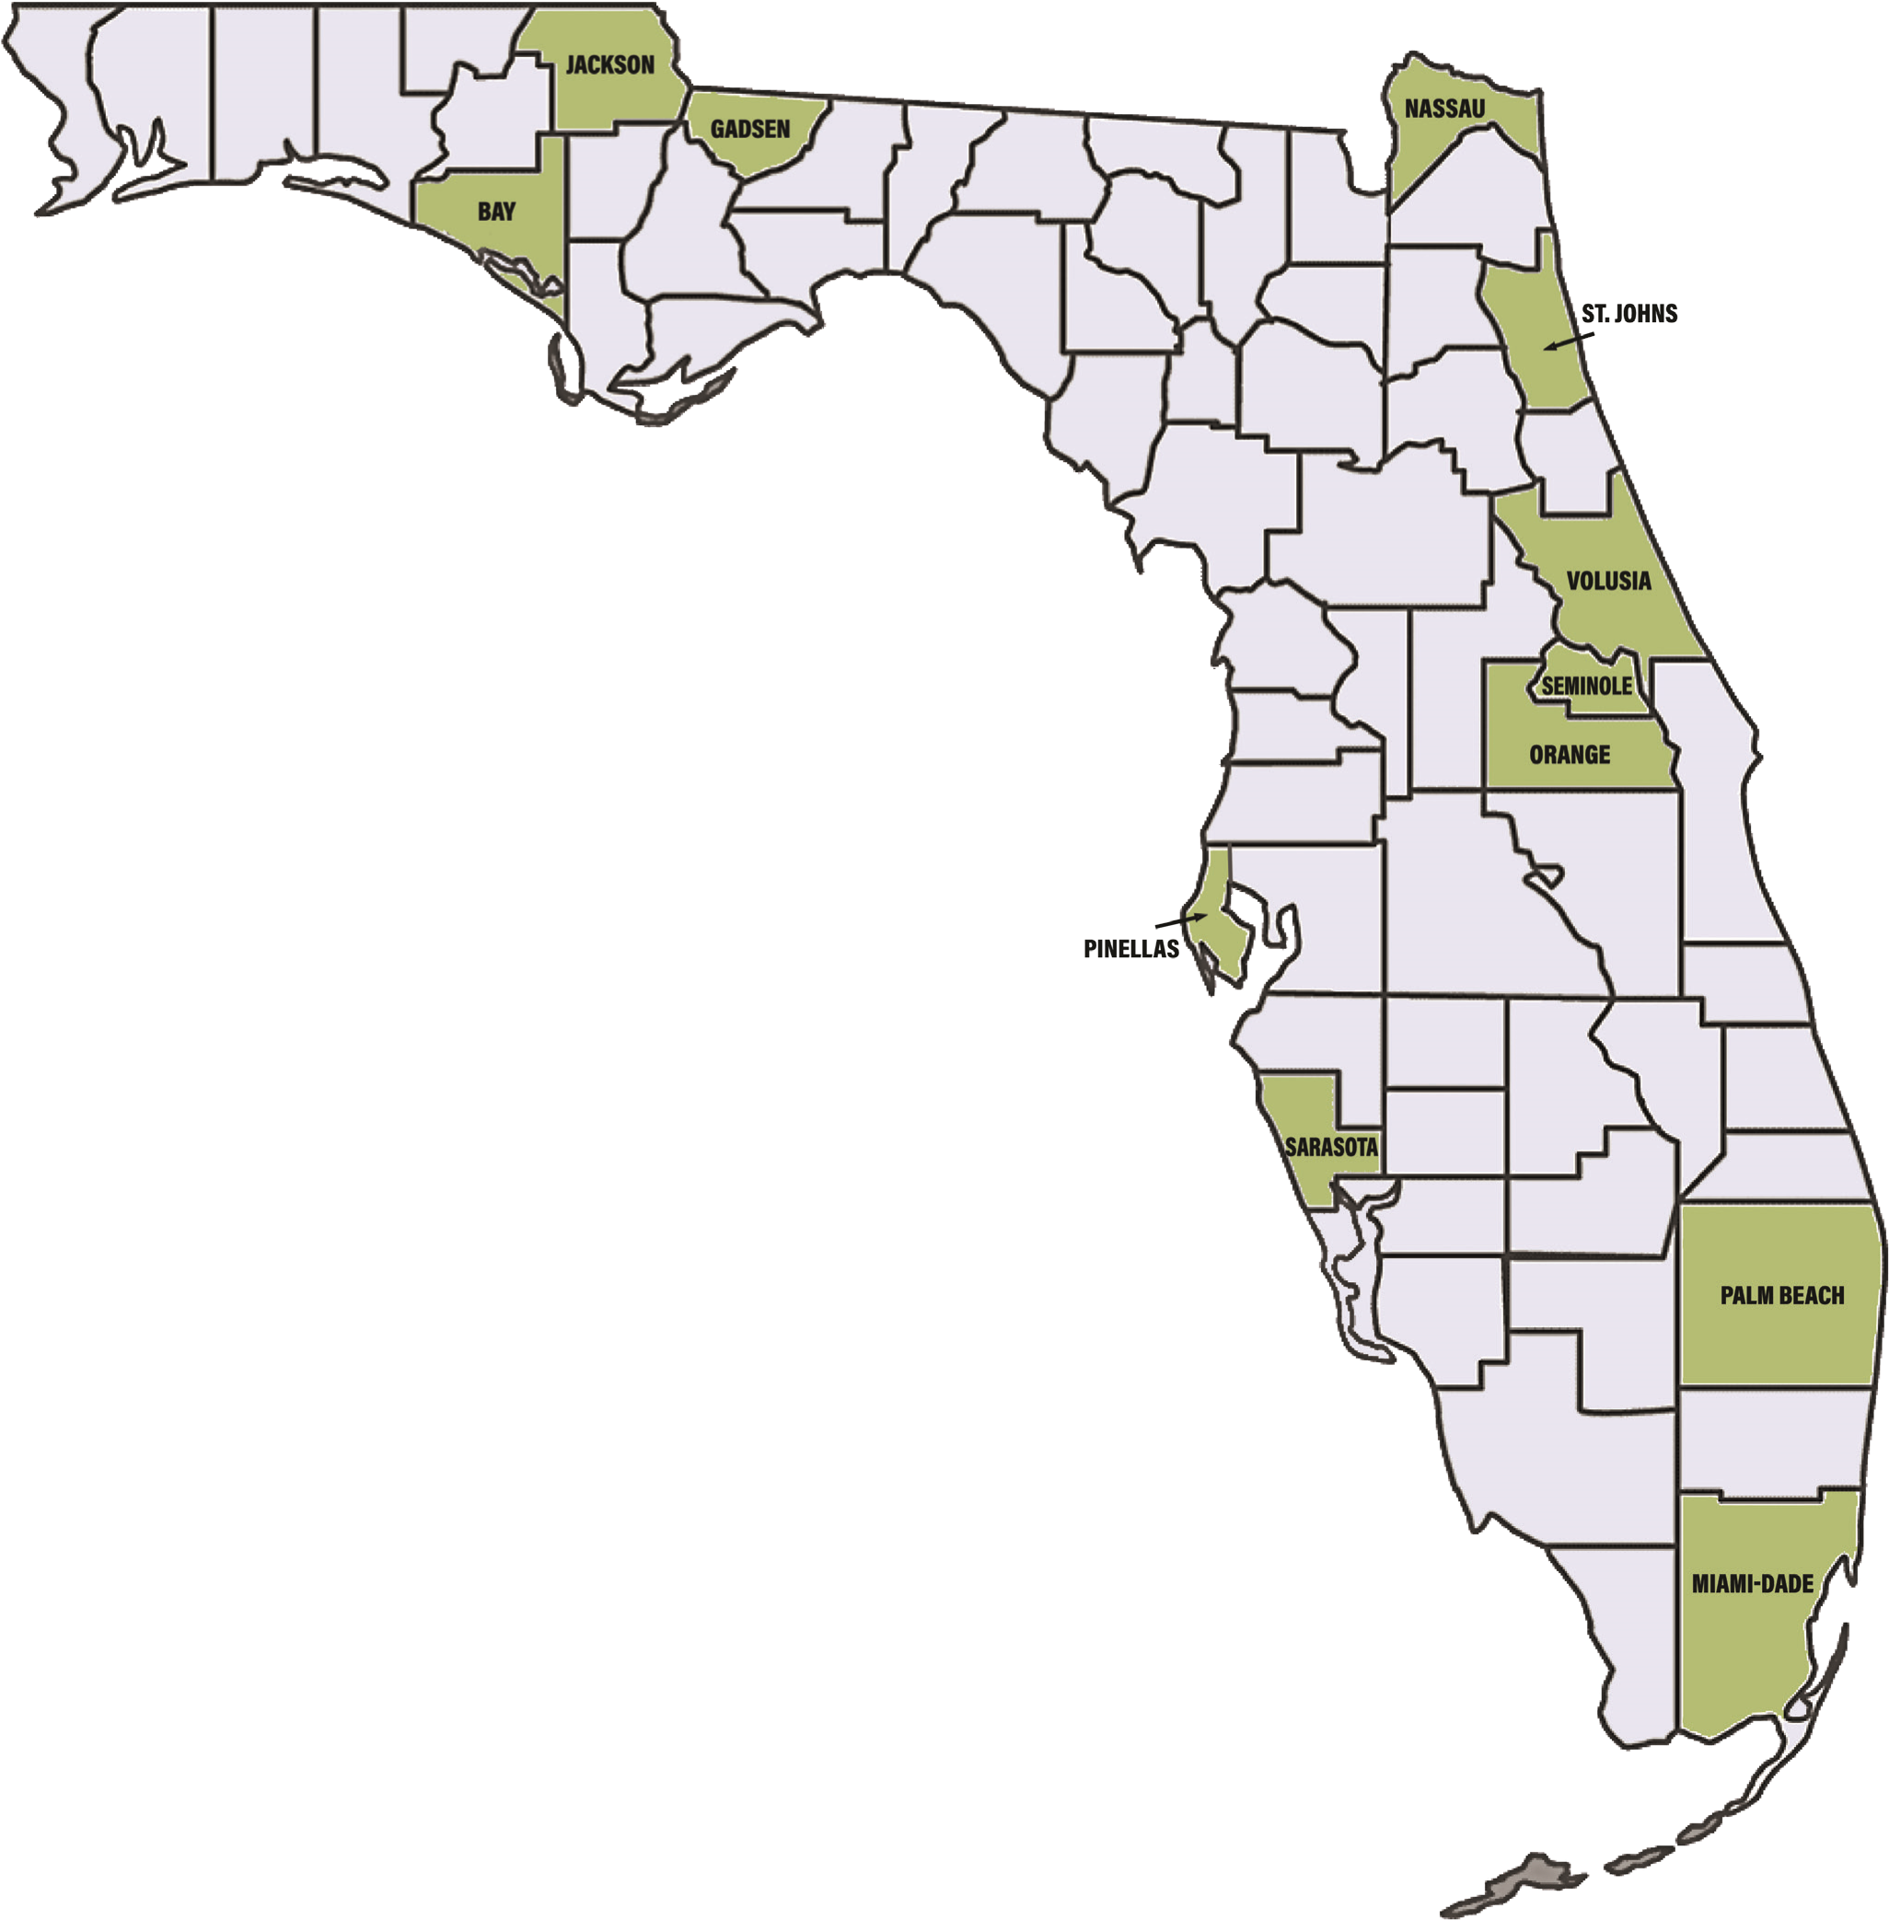

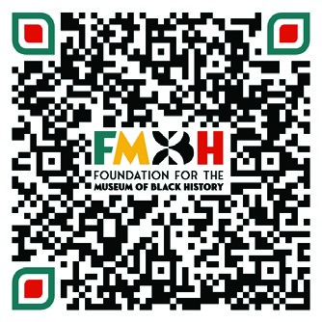
PRESERVING 450 YEARS OF LEGACY:
THE FOUNDATION SUPPORTING

FLORIDA’S BLACK HISTORY
These thirteen locations submitted
applications to be selected as the site
for the museum. Though St. Augustine/
St. Johns County was selected, the
geographical reach and historical
significance of each applicant is a
testament to the diversity of the history
and legacy that must be incorporated
into the museum.
•

Daytona Beach/Volusia
•

Eatonville/Orange County
•

Havana/Gadsden
•

Jackson County
•

Amelia Island/Nassau County
•

Opa-locka/Miami-Dade County
•

Panama City Beach/Bay County
•

Quincy/Gadsden
•

Sarasota/Sarasota County
•

Sanford/Seminole County
•

St Augustine/St Johns County
•

St Petersburg/Pinellas County
•

West Palm Beach/Palm Beach County
Sign Up To Stay Informed through

the FMBH Newsletter:
bit.ly/FMBHNewsletter

